Bahria University,

Karachi Campus



COURSE: CSC-113 COMPUTER PROGRAMMING

TERM: FALL 2019, CLASS: BSE- 1 (B)

Submitted By:

M MUAZ SHAHZAD 02-131202-081

(Name) (Reg. No.)

Submitted To:

Engr. Adnan ur rehman/ Engr. Ramsha Mashood

Signed Remarks: Score:

INDEX

|  |  |  |  |  |
| --- | --- | --- | --- | --- |
| SNO | DATE | LAB NO | LAB OBJECTIVE | SIGN |
| 01 | 04-NOV-2020 | 07 | FOR LOOP |  |
|  |  |  |  |  |
|  |  |  |  |  |
|  |  |  |  |  |
|  |  |  |  |  |
|  |  |  |  |  |
|  |  |  |  |  |
|  |  |  |  |  |
|  |  |  |  |  |
|  |  |  |  |  |
|  |  |  |  |  |
|  |  |  |  |  |
|  |  |  |  |  |
|  |  |  |  |  |
| SNO | DATE | LAB NO | LAB OBJECTIVE | SIGN |
|  |  |  |  |  |
|  |  |  |  |  |
|  |  |  |  |  |
|  |  |  |  |  |
|  |  |  |  |  |
|  |  |  |  |  |
|  |  |  |  |  |
|  |  |  |  |  |
|  |  |  |  |  |
|  |  |  |  |  |
|  |  |  |  |  |
|  |  |  |  |  |
|  |  |  |  |  |
|  |  |  |  |  |
|  |  |  |  |  |

Bahria University,

Karachi Campus



LAB EXPERIMENT NO.

**07**

LIST OF TASKS

|  |  |
| --- | --- |
| TASK NO | OBJECTIVE |
| 01 | Cube series without using power maths function. (Use For loop) |
| 02 | Square Series without using power maths function (use For loop) |
| 03 | Repeatedly print the value of the variable xValue, decreasing it by 0.5 each time, as long as xValue remains positive. |
| 04 | Print the square roots of the first 25 odd positive integers. |
| 05 | Make a game in C#, in which give 5 tries to the user to guess the value of the number. |
| 06 | Generate Stars using 2 for loops * ** *** **** ***** ****** |
| 07 | Write a program that reads from the console a positive integer number N (N < 20) and prints a matrix of numbers as on the figures below:  N = 3 N = 4 |

Submitted On:

**04/11/2020**

(Date: DD/MM/YY)

**Task No. 1:** **Cube series without using power math’s function. (Use For loop)**

**Solution:**namespace cube_series

{

class Program

{

static void Main(string[] args)

{

Console.WriteLine("====Cube series====");

Console.WriteLine();

for (int i = 1; i <= 10; i++)

{

Console.WriteLine("Cube of {0} = {1}",i, i*i*i);

Console.ReadKey();

}

}

}

}

**Output:**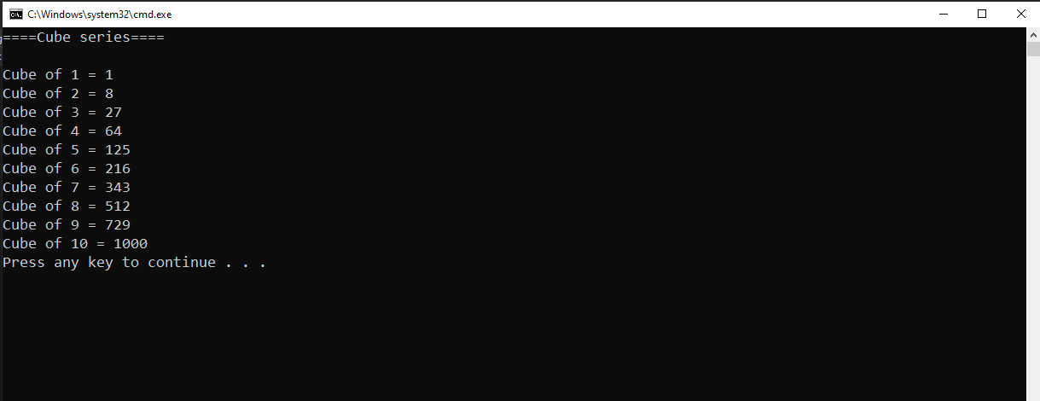

**Task No. 2: Square Series without using power math’s function (use For loop)**

**Solution:**namespace square_series

{

class Program

{

static void Main(string[] args)

{

Console.WriteLine("====Square series====");

Console.WriteLine();

for (int i = 1; i <= 10; i++)

{

Console.WriteLine("Square of {0} = {1}", i, i * i);

Console.ReadKey();

}

}

}

}

**Output:**

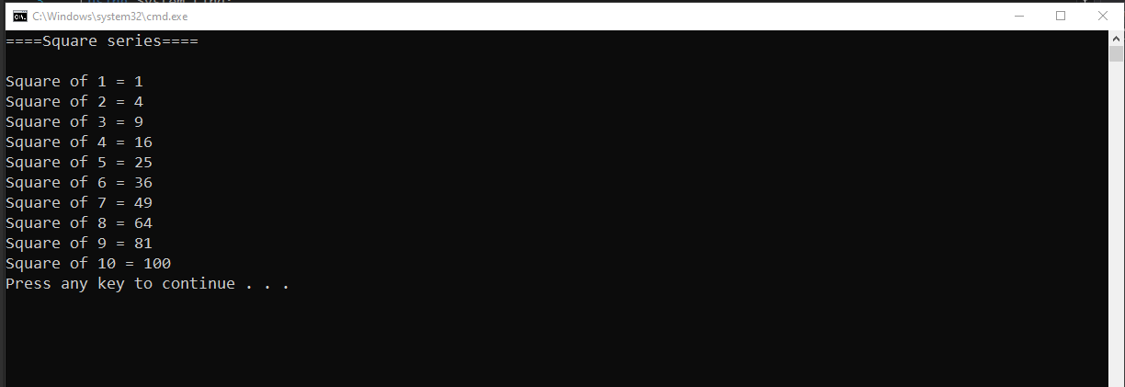

**Task No. 3: Repeatedly print the value of the variable value, decreasing it by 0.5 each time, as long as value remains positive**.

**Solution:**

namespace Xvalue_decreasing

{

class Program

{

static void Main(string[] args)

{

Console.WriteLine("Value of X Variable");

Console.WriteLine();

for (double i = -5; i<=0; i =i+0.5)

{

Console.WriteLine("{0}", i);

}

}

}

}

**Output:**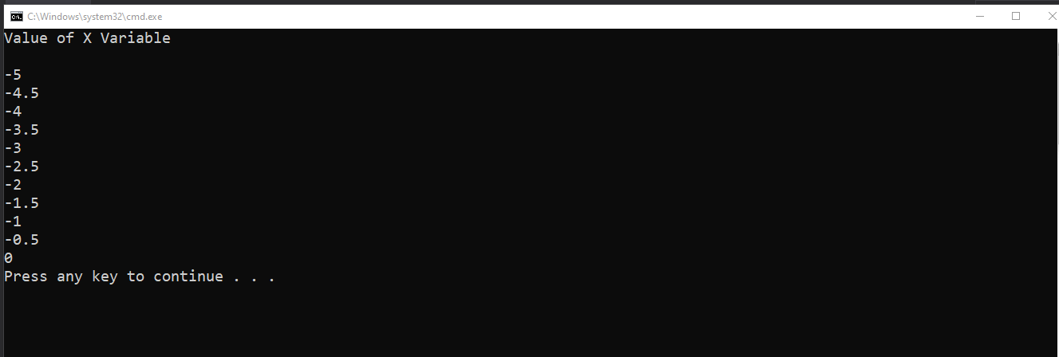

**Task No. 4:** **Print the square roots of the first 25 odd positive integers**

**Solution:**

namespace _25_odd_num

{

class Program

{

static void Main(string[] args)

{

Console.WriteLine("=====================");

Console.WriteLine("First 25 Odd Integers");

Console.WriteLine("=====================");

Console.WriteLine();

for (double i = 1; i <= 50; i = i + 2)

{

Console.WriteLine("Square Root Of {0} is {1}", i, Math.Sqrt(i));

}

}

}

}

**Output:**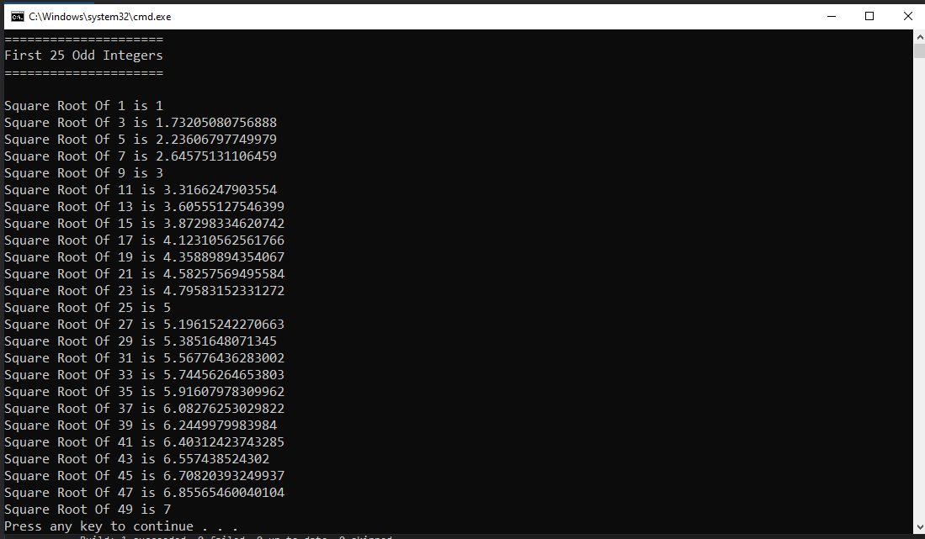

**Task No. 5: Make a game in C#, in which give 5 tries to the user to guess the value of the number.**

**Solution:**

namespace game

{

class Program

{

static void Main(string[] args)

{

int j = 20, i;

Console.WriteLine("\t===============");

Console.WriteLine("\tWelcome To Game");

Console.WriteLine("\t===============");

Console.WriteLine("\n*Guess The Correct Number & You Have Only Five Tries*");

Console.WriteLine("\n*Press Enter Key*");

Console.ReadLine();

Console.WriteLine("\nGuess The Number");

for (int k = 1; k <= 5; k++)

{

Console.Write("Enter Guessed Number: ");

i = Convert.ToInt32(Console.ReadLine());

if (i != j)

{

Console.WriteLine("================");

Console.WriteLine("Wrong, Try Again");

Console.WriteLine("================");

}

else

{

Console.WriteLine("\nCongratulations You Have Guessed The Secret Number");

break;

}

}

}

}

}

**Output:**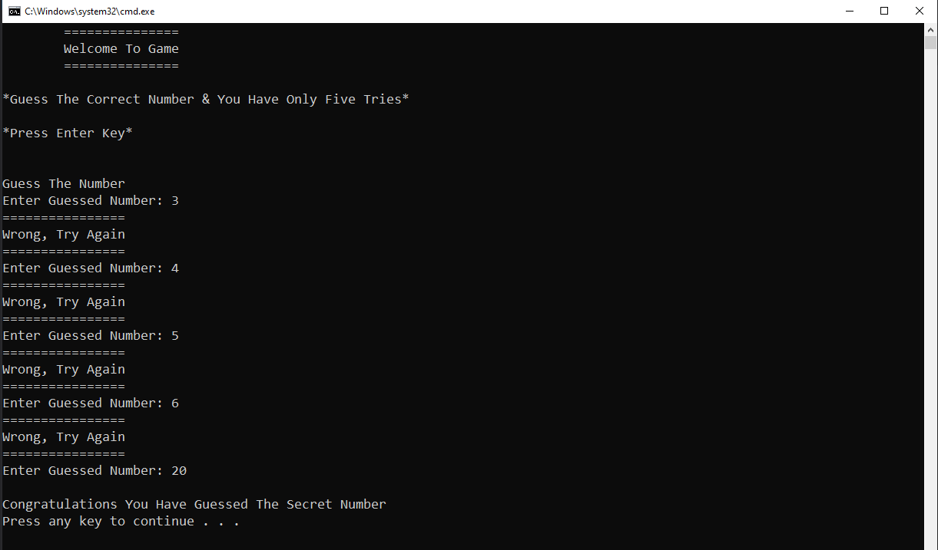

**Task No. 6:** **Generate Stars using 2 for loops  
 *  
 **  
 ***  
 ****  
 *****  
 \*\*\*\*\*\***

**Solution:**namespace task_6_lab_7

{

class Program

{

static void Main(string[] args)

{

for (int i = 1; i <= 6; i++)

{

for (int j = 1; j <= i; j++)

{

Console.Write("* ");

}

Console.Write("\n");

}

}

}

}

**Output:**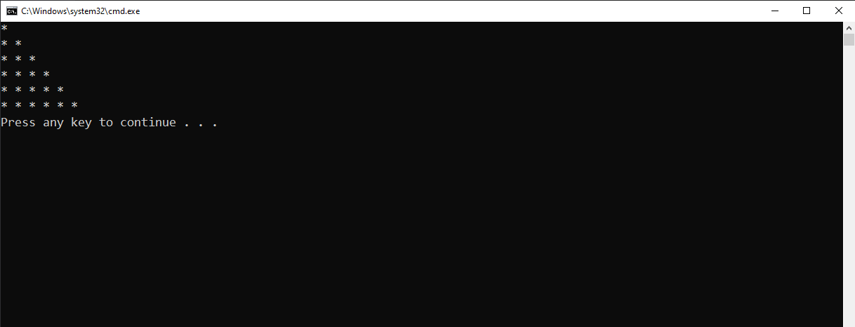

**Task No. 7:** **Write a program that reads from the console a positive integer number N (N < 20) and prints a matrix of numbers as on the figures below:**

**N = 3 N = 4**

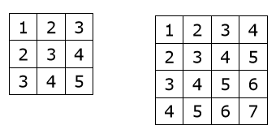  
  
**Solution:**namespace Matrices

{

class Program

{

static void Main(string[] args)

{

int f;

Console.Write("Enter Number Less Than 10: ");

f = Convert.ToInt32(Console.ReadLine());

if (f < 20)

{

for (int i = 0; i < f; i++)

{

for (int j = 1; j < f + 1; j++)

{

Console.Write("{0,6}", i + j);

}

Console.Write("\n");

}

}

}

}

}

**Output:**